27.23: a) 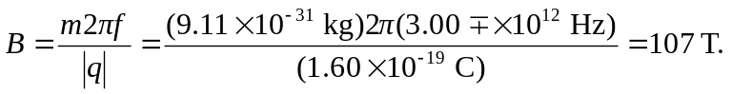
This is about 2.4 times the greatest magnitude yet obtained on earth.
b) Protons have a greater mass than the electrons, so a greater magnetic field would be required to accelerate them with the same frequency, so there would be no advantage in using them.

